Week 37
English I CP
May 1-5

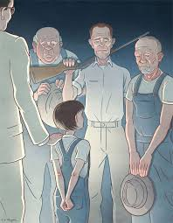

M: AIR TESTING: AMERICAN HISTORY: Review the information of chapters 26-27
HMWK: Read chapter 28-29

T: Please answer journal prompt
Discuss with class
Silently read chapters 30-31
HWMK: Finish the book

W: CCSS.ELA-Literacy.W.9-10.1.d
Determine a theme or central idea of a text and analyze in detail its development over the course of the text, including how it emerges and is shaped and refined by specific details; provide an objective summary of the text.
HMWK: finish Theme activity

TH: Write Editorial
HMWK: finish editorial for homework ---turn in Friday- as rough draft

F: Naviance Training----report to Innovation Center lab 103

Socratic Seminar Research and training will begin next week

